

EXPERIMENT 1

Execute and display the results for the following commands in Kali Linux Operating Systems: rm command users command tree command

AIM
To Execute and display the results for the following commands in Kali Linux Operating Systems: rm command users command tree command

PROCEDURE
- Open Kali Linux
- Open terminal
- rm command
  - touch sample1.txt -- press Enter
  - ls -- press Enter
  - touch sample2.txt -- press Enter
  - ls -- press Enter
  - touch sample3.txt -- press Enter
  - ls -- press Enter
  - touch sample4.txt -- press Enter
  - ls -- press Enter
  - touch sample5.txt -- press Enter
  - ls -- press Enter
  - rm sample5.txt -- press Enter
- tree command
  - tree -- press Enter
  - mkdir EH -- press Enter
  - cd EH -- press Enter
  - touch Lile1.txt -- press Enter
  - tree -- press Enter
  - mkdir Unit1 -- press Enter
  - cd Unit1 -- press Enter
  - touch topic1.txt -- press Enter
  - touch topic2.txt -- press Enter
  - touch topic3.txt -- press Enter
  - touch topic4.txt -- press Enter
  - touch topic5.txt -- press Enter
  - tree -- press Enter

OUTPUT
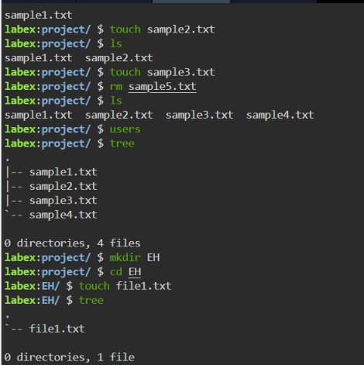
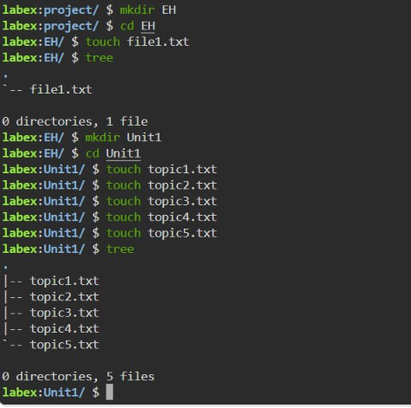
RESULT
The results for the following commands in Kali Linux Operating Systems: rm command users command tree command was successfully executed

